Subject: Prime Audiology - Website Final Requirements & Client Feedback
Hi
Thanks for the initial sample link (https://prime-audiology.onrender.com/). We have just reviewed the final requirements and competitor references with the client.
Moving forward, the website must strictly adhere to the Prime Audiology Brand Book (Montserrat for headings, Nunito Sans for body, Deep Navy and Bright Blue color palette). Because the target demographic is 60+ seniors, the UX must feature high contrast, large text (minimum 16px body), and a sticky header with the phone number clearly visible.
Reference link provided by the client

https://www.heartek.com.au/
https://www.smarthearing.au/

https://audiencehearing.com.au/?utm_source=gbp&utm_medium=profile

https://essenceaudiology.com.au/?utm_source=gmb&utm_medium=organic

https://hearingconsultants.com.au/

Please review the finalized Sitemap and Feature Requirements below based on the client's direct requests.

1. Sitemap & Navigation Structure
Based on the client's reference (Image 1), the main navigation must include:
- Home
- About Us (Include George Sebastian's bio)
- Services (Drop-down for Ear Wax Removal, Home Visits, etc.)
- Hearing Aids (Drop-down menu below)
  - Styles & Types
  - Price & Technology
  - Pensioners & HSP Eligibility
- Blog
- FAQ
- Contact Us (With clear CTA for "Request Appointment" and Phone Number)

2. MUST-HAVE Features (Core Client Requirements)
These items must be built into the site structure as requested by the client:
- Price & Technology Matrix: We need a clean, easy-to-read table comparing technology levels (e.g., Standard, Essential, Advanced, Premium, Elite) to Lifestyle Aspects (Quiet environments, active social life, etc.). Reference: See attached HearTEK images 2, 3, and 4.
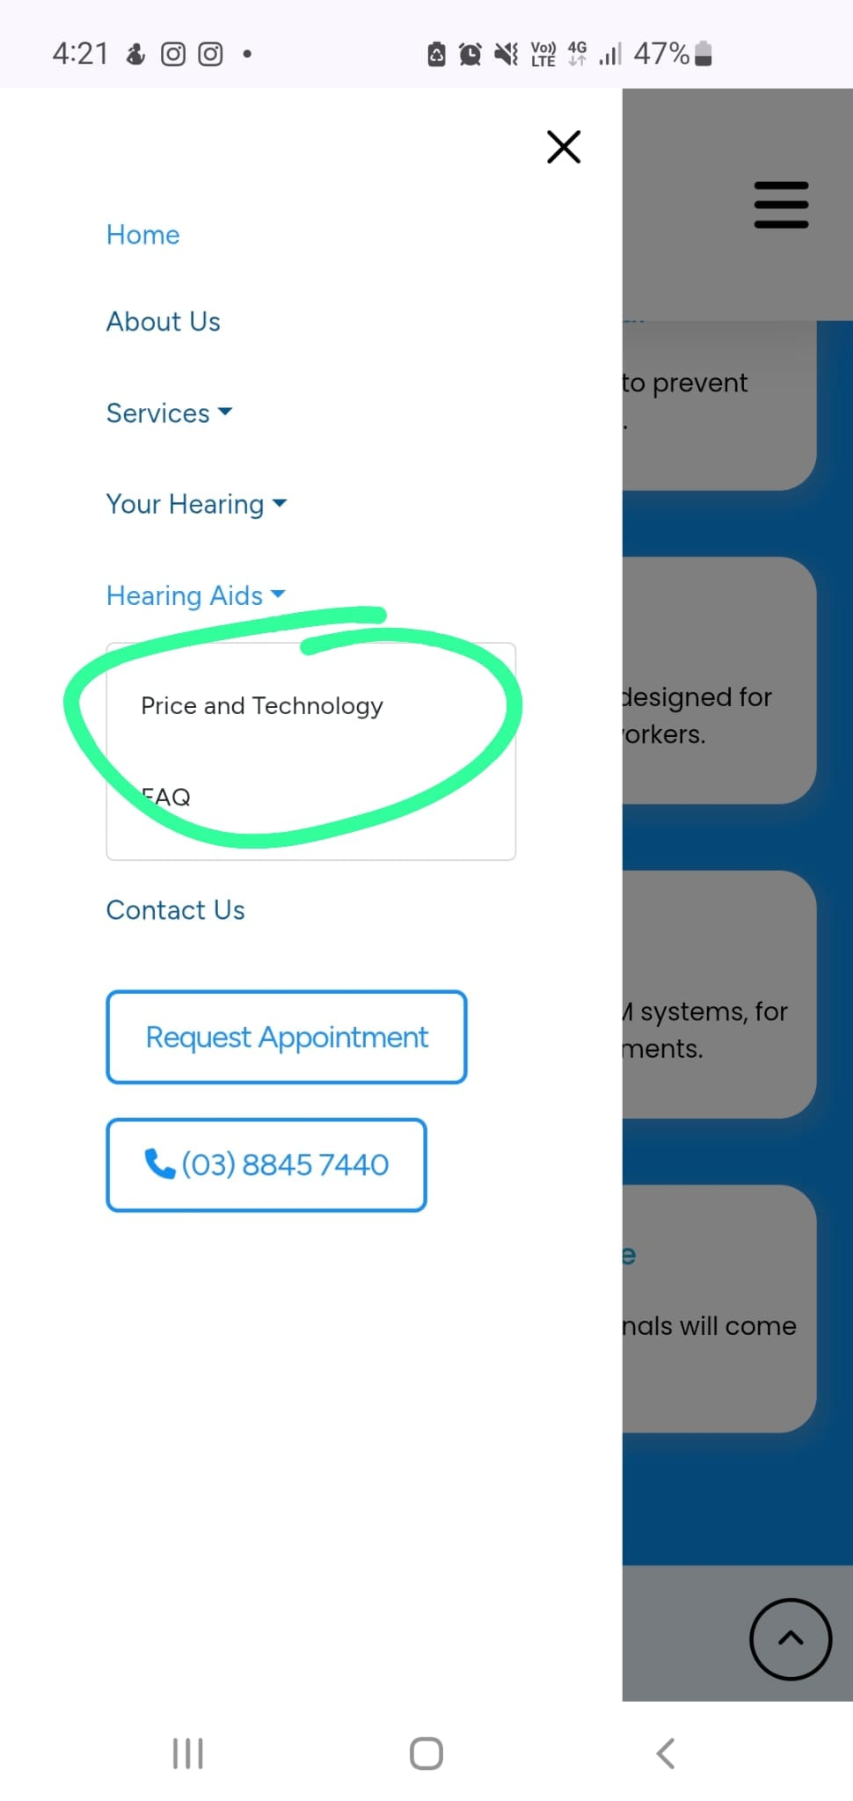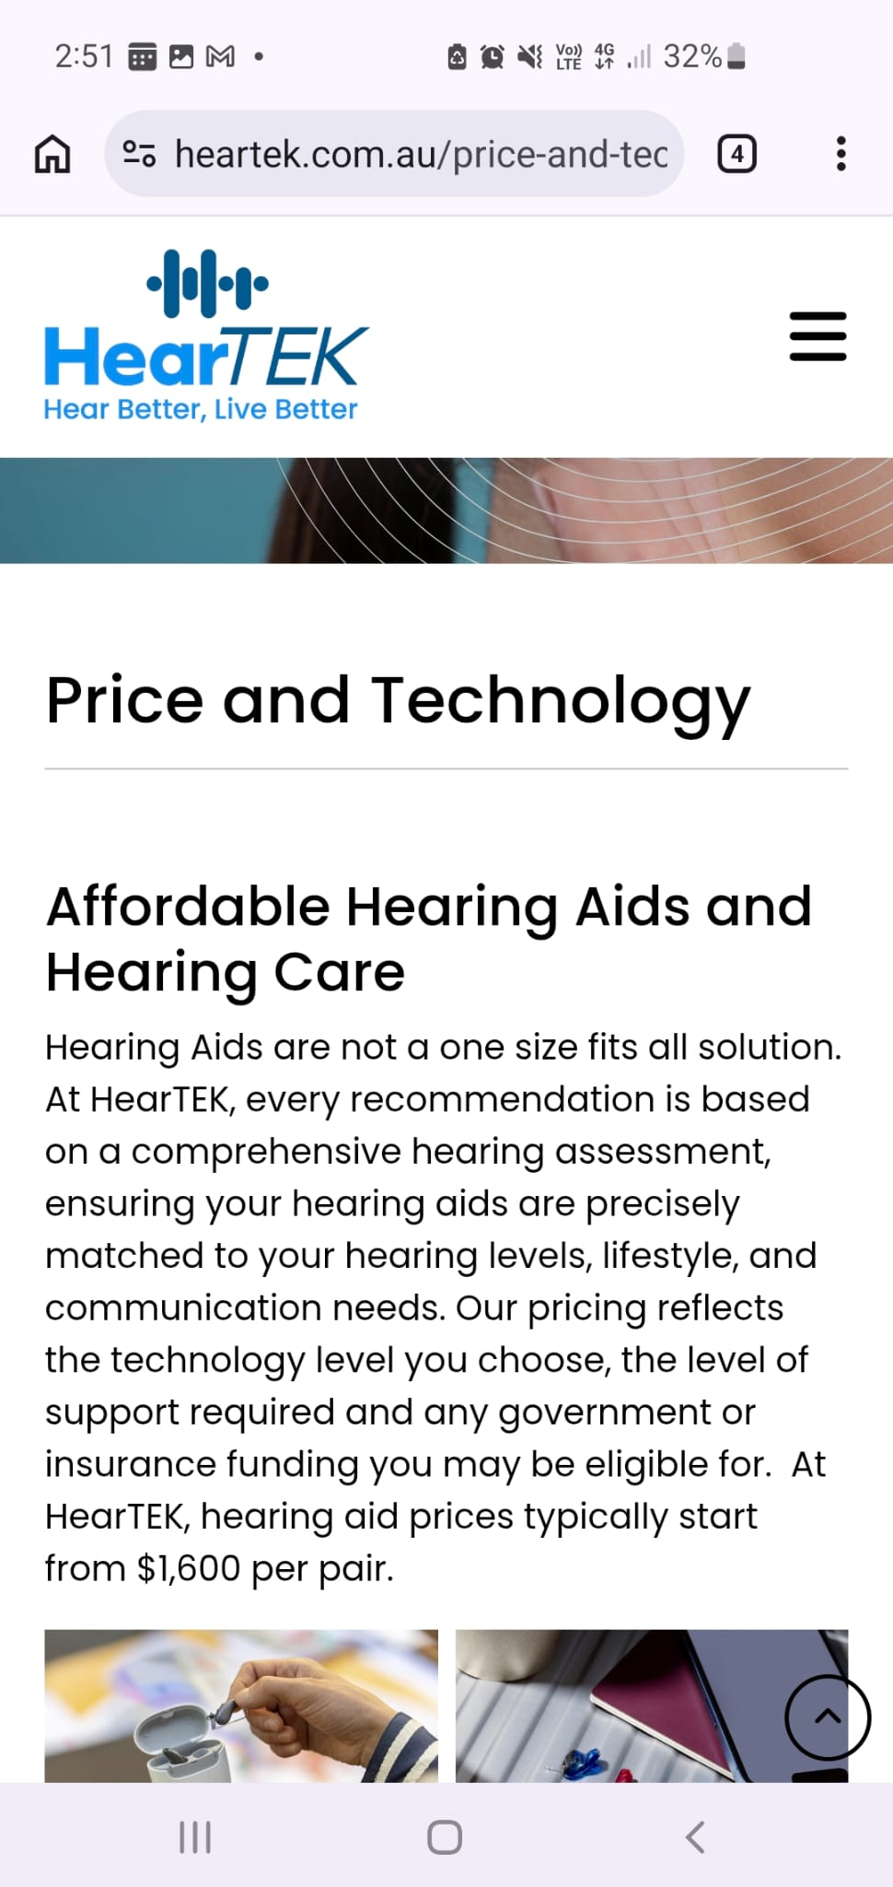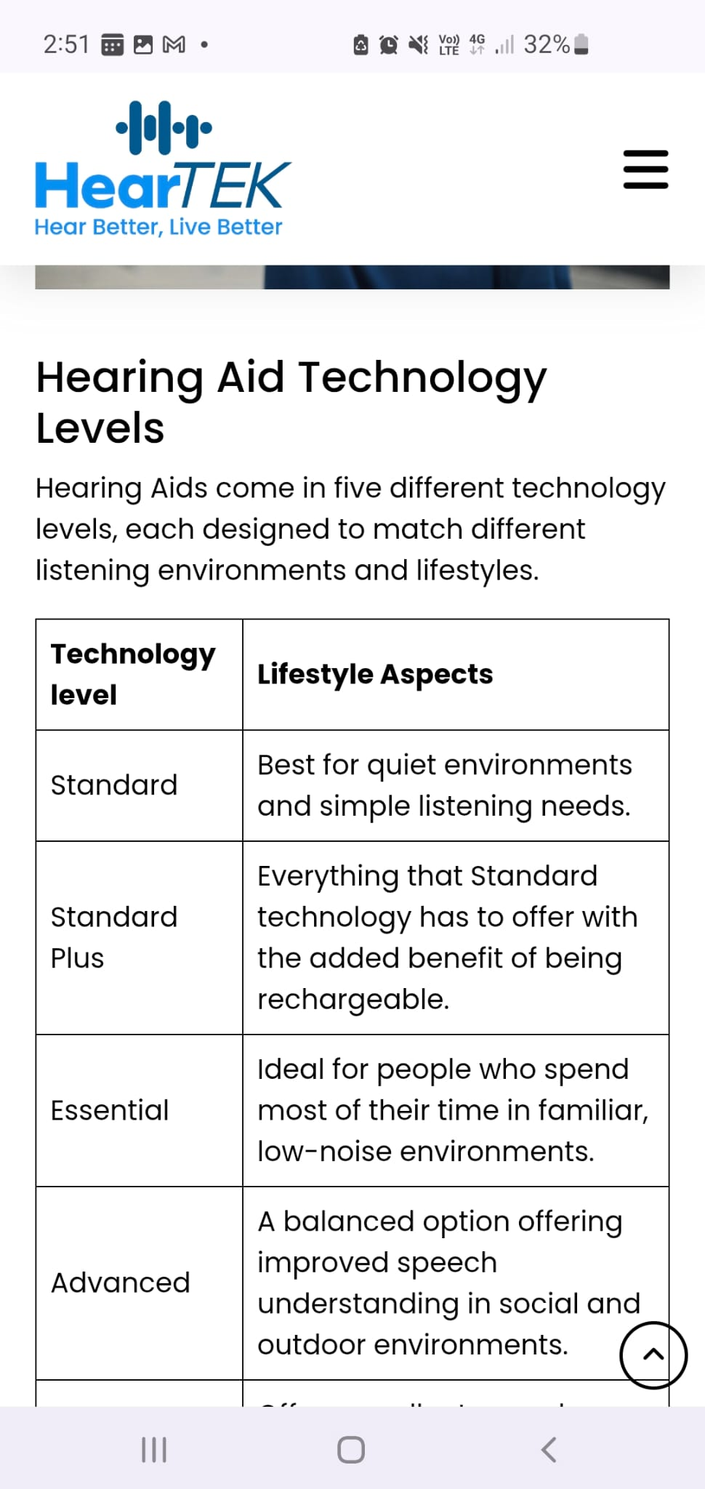
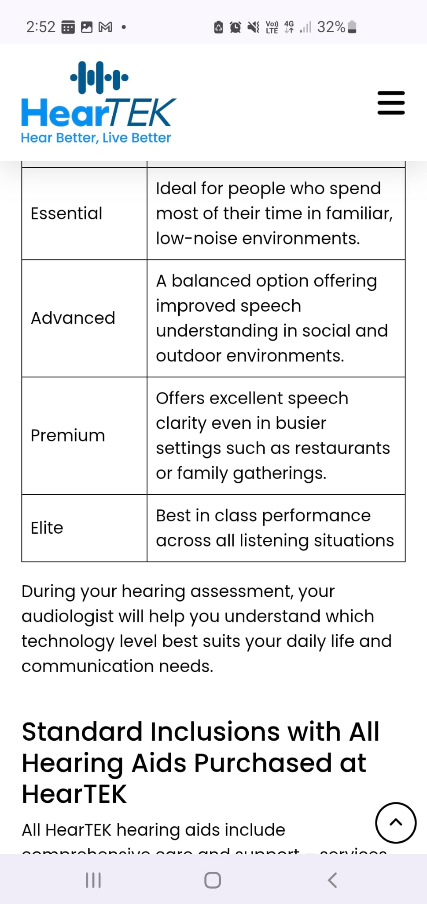
- Hearing Aid Styles Section: A visual grid showing the different types of hearing aids (BTE, RIC, ITE, ITC, CIC, IIC) with clear images. Reference: See attached SmartHearing image 6.
https://www.connecthearing.com.au/types-of-hearing-aids/phonak-infinio-ultra/?utm_source=google&utm_medium=cpc&utm_campaign=bau&gad_source=1&gad_campaignid=23849907977&gbraid=0AAAAADe1o3b-gYFIz_ntjzr_EHxAXv0j5&gclid=CjwKCAjwwfnUBhAtEiwAfQpAYl6gzo3xic-khyNAlC4qWtJOPFV5n5P1PuFHjxSpQ18zyYuJj1yFYBoChD4QAvD_BwE

- https://www.phonak.com/en-au/professionals/new-at-phonak

- https://www.starkey.com.au/?gad_source=1&gad_campaignid=23515231837&gbraid=0AAAABCvCjO3B69ZLo3wt_pXNXzn-gzNby&gclid=CjwKCAjwwfnUBhAtEiwAfQpAYpl0vtb_92FKOQ6p-oJJwJtD2YvngTBpvDgvg7gN0PPCMbpSjXFEHxoClvMQAvD_BwE
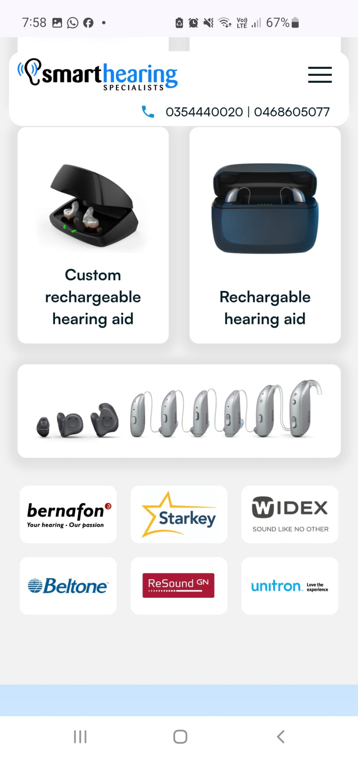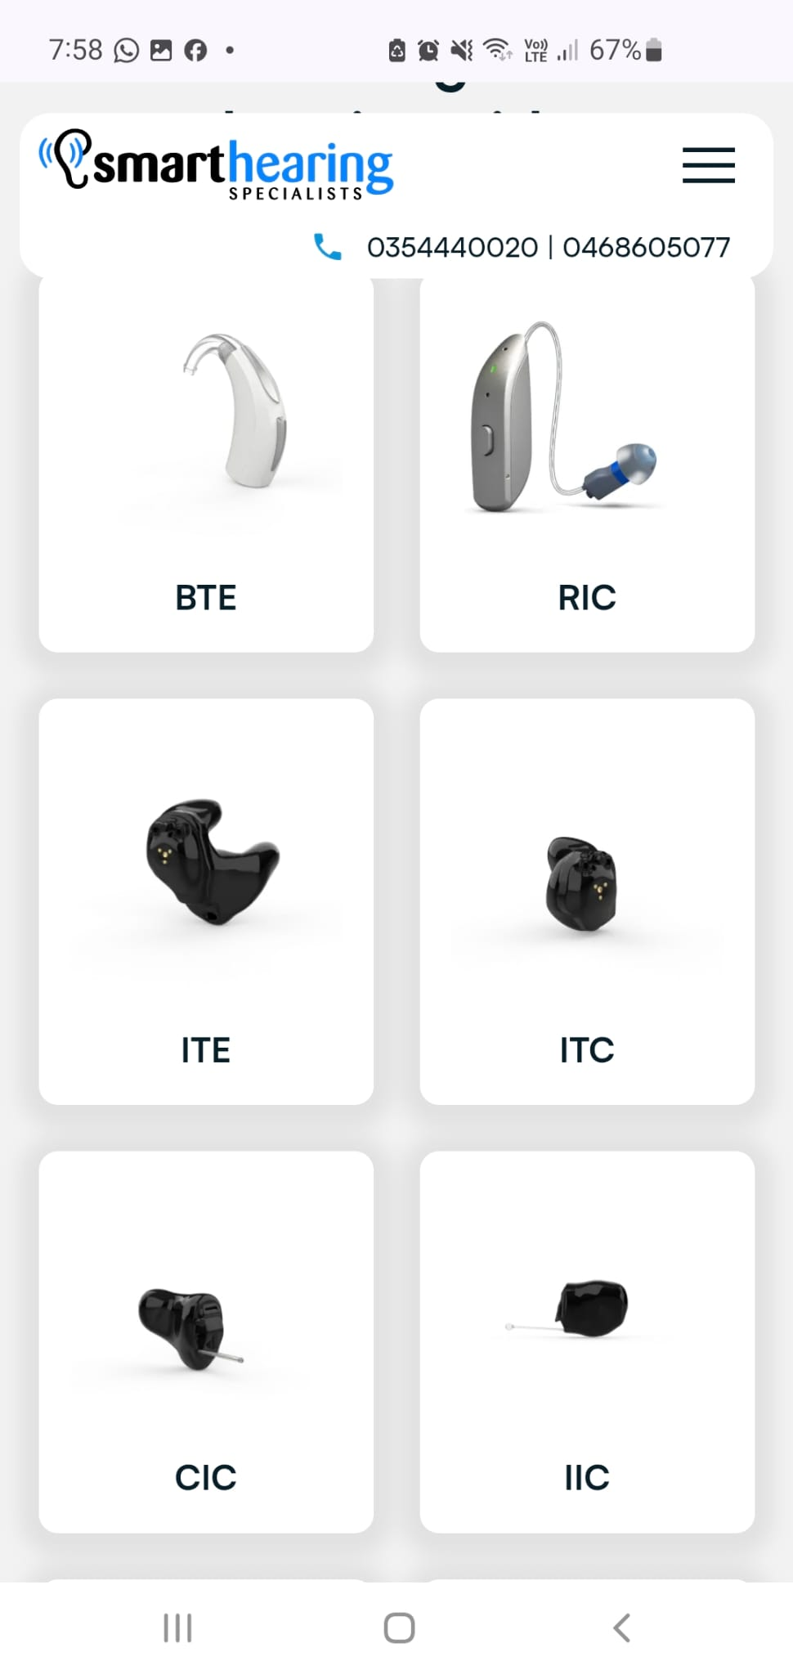
- Pensioners & HSP Eligibility Page: A dedicated page explaining Government-funded hearing support (Pensioner Concession, DVA Gold/White Card, ADF membership). Reference: See attached Freedom Hearing image 5.
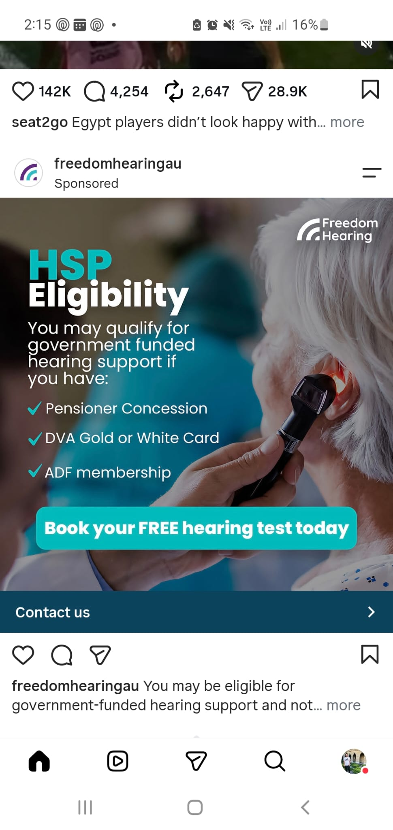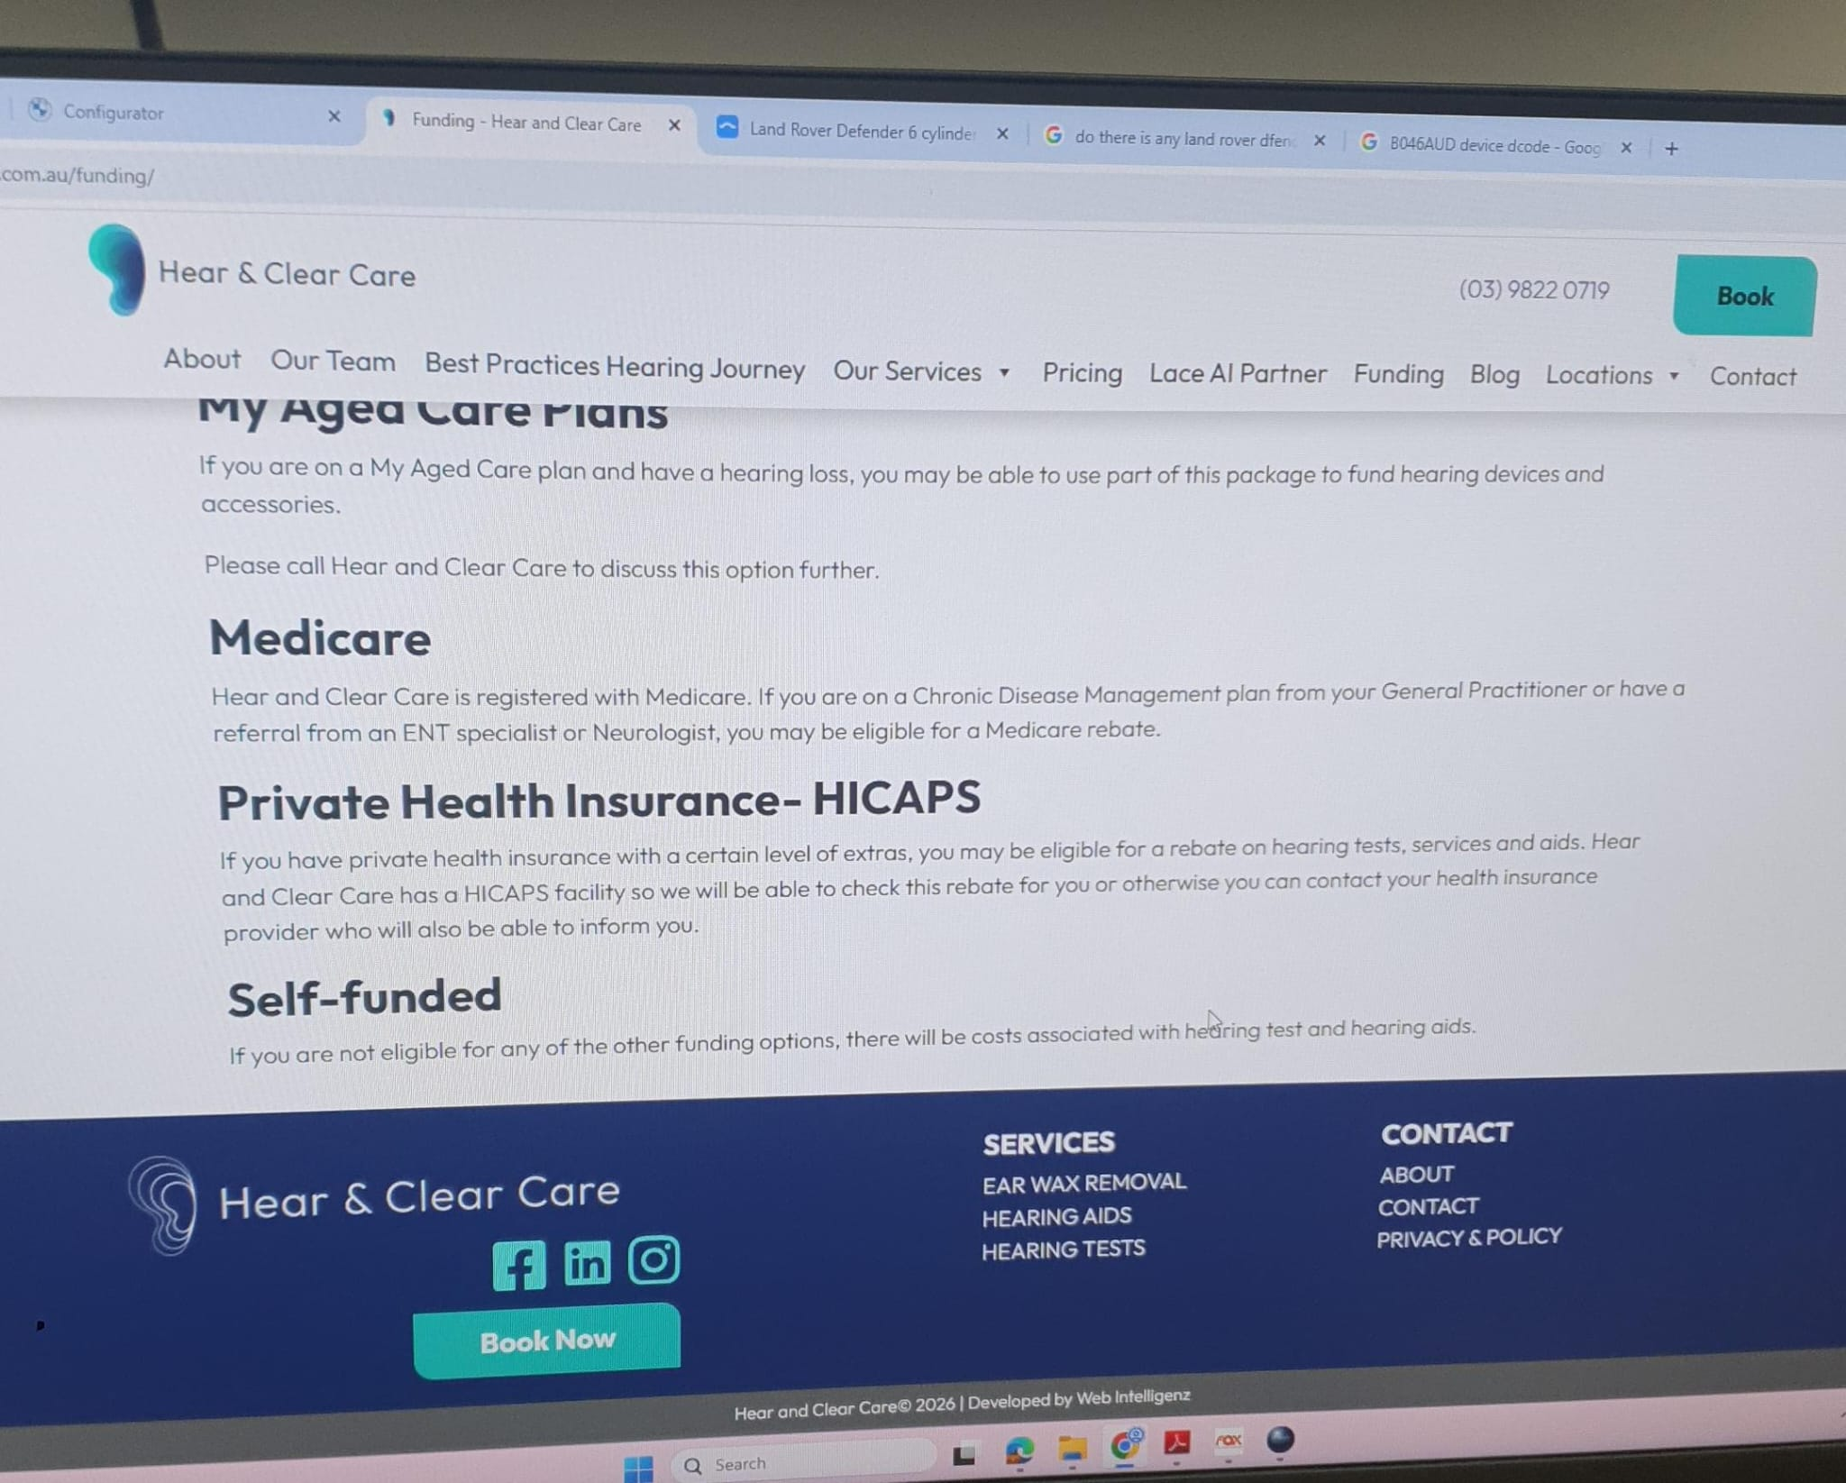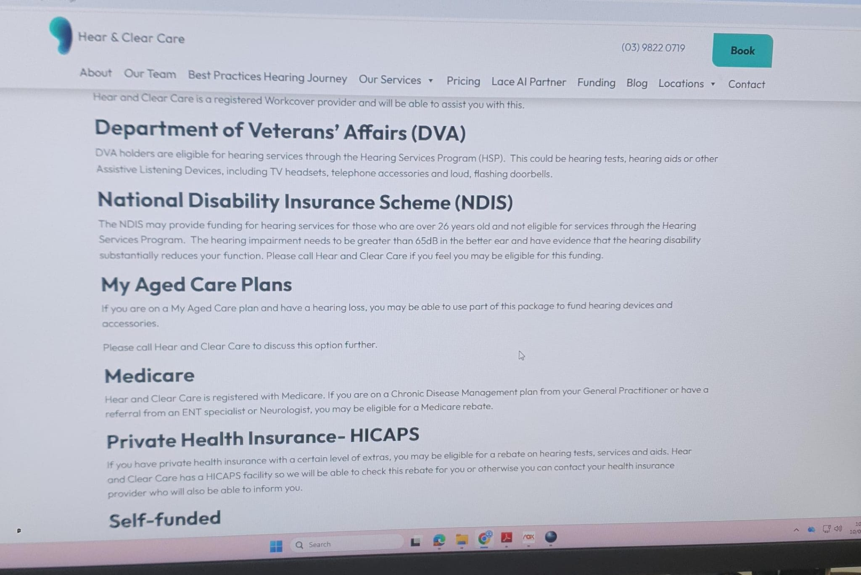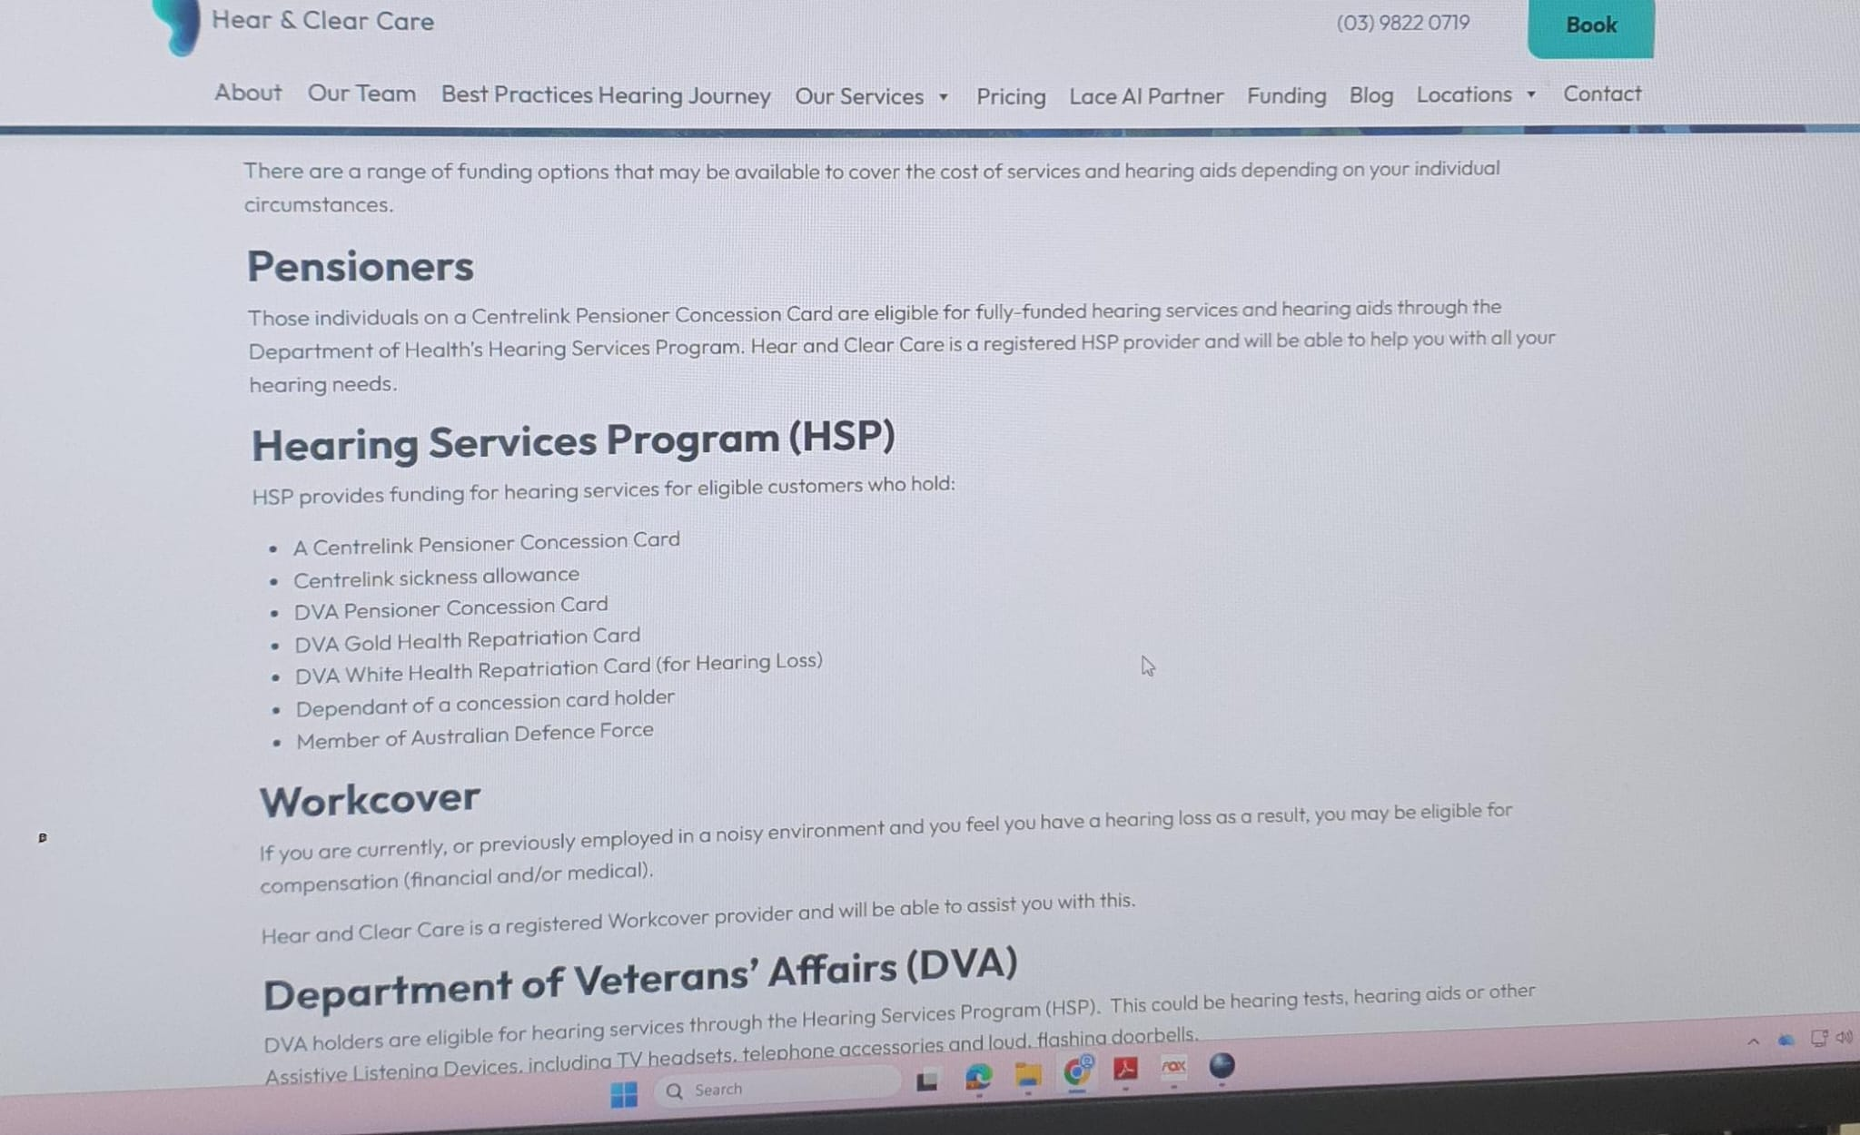
- Partner Brands Grid: A trust-building logo grid showing the brands Prime Audiology dispenses (Phonak, Starkey, Oticon, Bernafon, Widex, Resound, Signia, etc.). Reference: See attached True Hearing image 8.
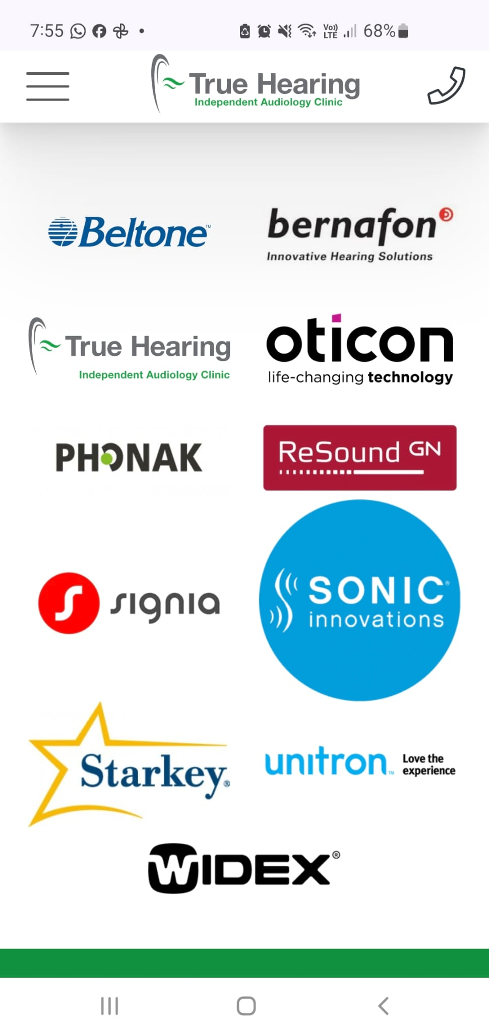
- Blog/News Layout: A clean, easy-to-read blog layout for articles like "What is Ear Wax Removal?" and "Hearing Aids in Australia." Reference: See attached Audience Hearing image 9.
https://audiencehearing.com.au/second-opinions-for-hearing-treatment/
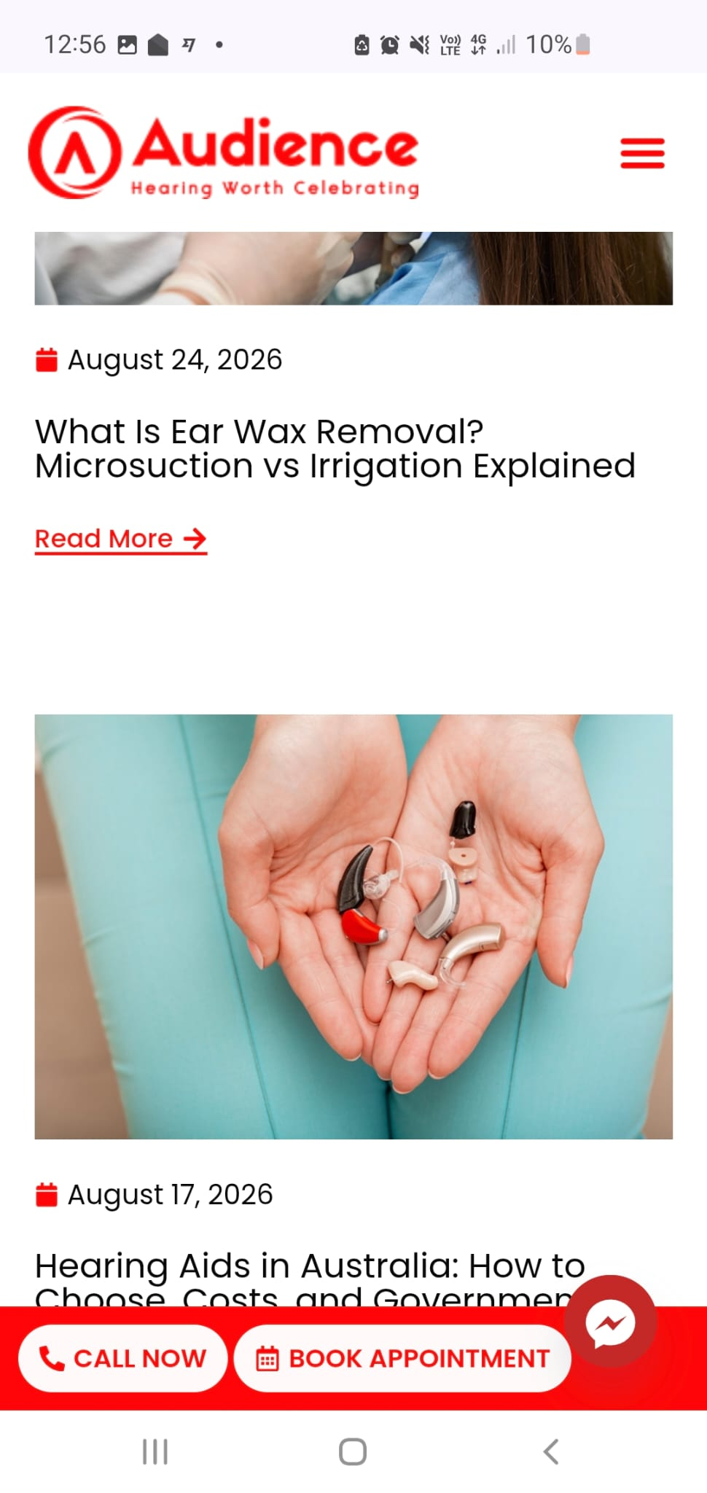
Appointments & Booking Integration (Core Requirement) The appointment booking process must be completely frictionless and cater to our two distinct audiences: Seniors (who prefer to call) and Adult Children (who prefer to book online).
- Global Visibility: A "Request Appointment" CTA button and the clinic's phone number must be permanently visible in a sticky header across all desktop and mobile pages.
- Dedicated Booking Page: Create a dedicated "Book Appointment" page.
- Dual Booking Options: The booking page must clearly offer two paths:
  - Call the Clinic: Display the phone number in large, clickable text (tel: link) for mobile users.
  - Book Online: Provide a space for an embedded booking widget.
- Fallback Form: Until the client provides their specific booking widget code, please build a clean, highly legible fallback contact form (Fields: Name, Phone, Email, Preferred Date/Time, and a drop-down for "Reason for visit: Hearing Test, Ear Wax Removal, Hearing Aid Fitting, Other"). Form submissions must route to admin@primeaudiology.com.au.
- Email & Domain Setup: Ensure forms are routed to: GEORGESEBASTIAN@primeaudiology.com.au and admin@primeaudiology.com.au.

3. NEGOTIABLE / COMPLEX Features (How to handle these)
The client requested some complex multimedia features. Here is how we want them executed to maintain site speed and budget:
- "Motion 360-degree 3D interactive pictures of products":
  - Instruction: Do not custom-build 3D models. Please utilize official iFrame/embed codes provided directly by manufacturers (like Phonak or Starkey) if they offer 360-degree widgets. If manufacturer widgets are unavailable, fallback to high-quality GIFs or hover-state image flippers to simulate the 360 effect without heavy code.
- "How hearing aids work video (sound production to brain)":
  - Instruction: We do not need custom animation. Please source a high-quality, professional educational video from YouTube (preferably from a major brand like Phonak or an official medical channel) and embed it cleanly into the "Your Hearing" or "About" page.
- Specific Products (Phonak Infinio Ultra, Starkey, etc.):
  - Instruction: Create a "Featured Technology" or "Latest Releases" section on the Hearing Aids page that highlights these specific models using high-res images and summaries derived from the links the client provided.

4. Compliance Note
As this is an Australian medical website, it must comply with AHPRA guidelines. Do not include patient testimonials anywhere on the site, and avoid language that "guarantees" a cure for hearing loss.
Please let me know if you need any clarification on these requirements or if you foresee any technical roadblocks with the 360/Video embeds.

